**Closed architecture and database access**

**Closed architecure**

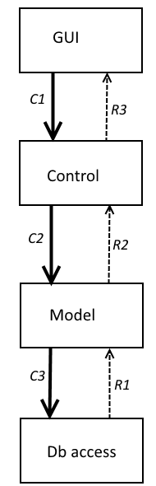

**Explanation**

GUI can only call Control.

Control can only call Model.

Model can only call Db access.

In most strict form:

GUI only knows Control.

Control only knows Model.

Model only knows Db access.

**Read**

C1 – search data as parts

C2 – search data as parts

C3 – search data as parts

R1 – return read data as parts

Model creates data objects

R2 – return data objects

Control creates GUI ready data as string *)

R3 – return string ready for GUI *)

*)

The above is 1 of 3 possibilities.

Others are:

* R3 – return data objects (means GUI layers knows Model layer)
* Control creates objects prepared for GUI.  
  R3 – return objects for GUI

**Write**

C1 – input data as parts

C2 – input data as parts

Model creates data object

C3 – input data as object

R1 – return value

R2 – return value

R3 – return value

**Comments**

Closed architecture is in a way better structured – but maybe not so intuitive.

From an object-oriented perspective it’s not optimal, as it uses data parts and strings instead of objects.